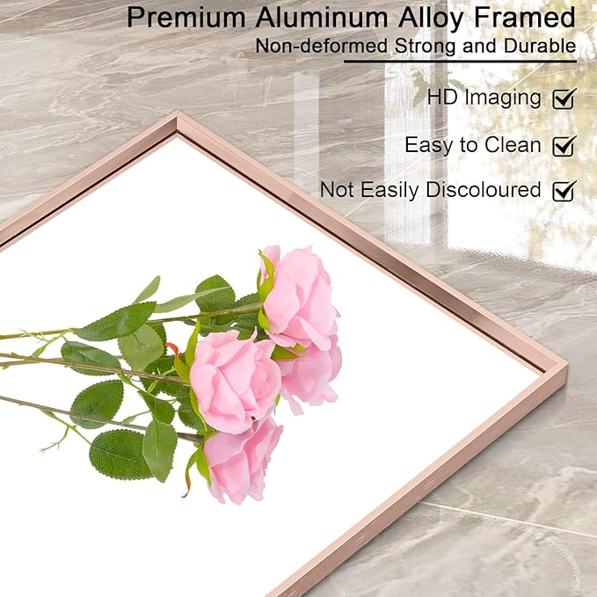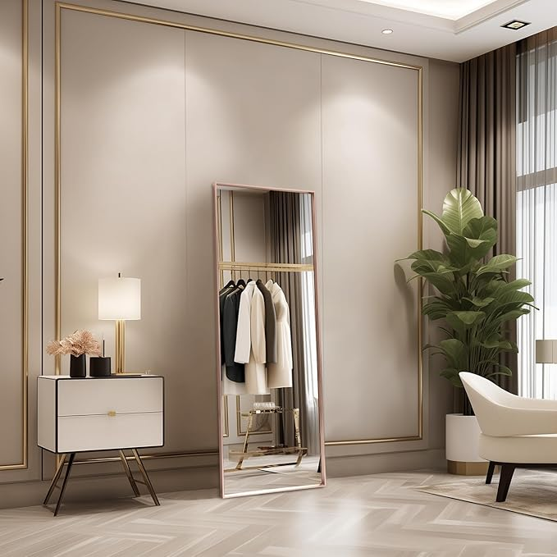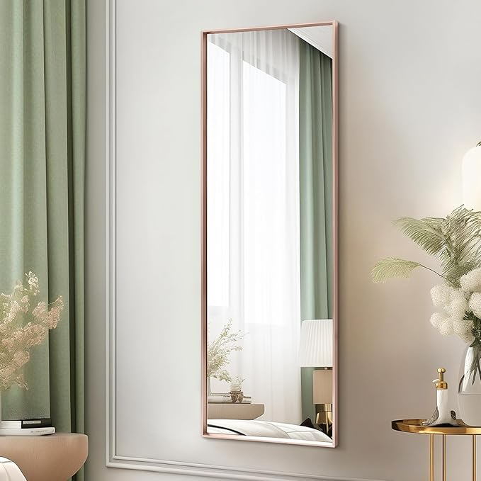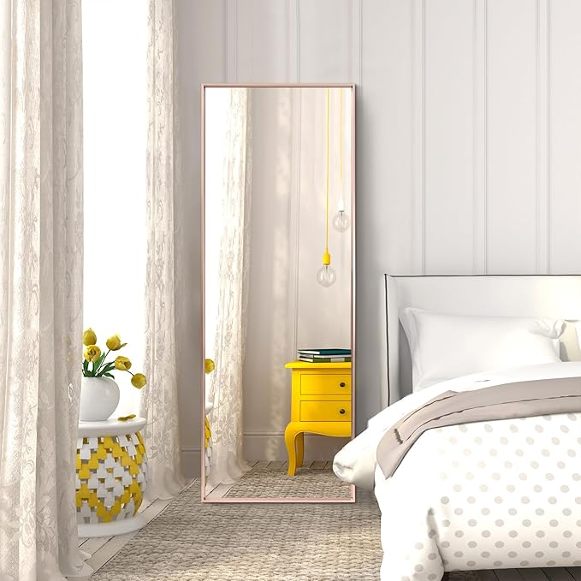

AAZZKANG Large Wall Mirror Full Length with Metal Framed 43"x14" Rectangular Full Body Mirrors for Bedroom Living Room Bathroom Dressing Room Home Entryway

**PRODUCT DESCRIPTION:**

|  |  |
| --- | --- |
| Brand | AAZZKANG |
| Room Type | Bathroom, Bedroom, Home Office, Livng Room, Hallway |
| Shape | Rectangular |
| Product Dimensions | 43"L x 14"W |
| Frame Material | Wood |

**About this item**

* Large Full Length Mirror: 43" length,14" width, long and big enough for you to sweep your entire figure from head to toe;Whether you’re applying make up or choosing your outfit of the day, our large mirror offers a crystal-clear reflection for complete convenience and confidence
* Metal Frame Mirror: The wall mirror is made of premium aluminum alloy frame,which is non-deformed,strong,and brushed craft protects its surface from wearing,can be used continuously for years,adding luster to your home
* HD Glass: High-definition,clear glass, provide distinct and lifelike image and well-lit reflection;The glass mirror is secured and embedded in the frame and reinforced with solid backing for added stability.Crafted of thick
* Multiple Uasge: This full length door mirror can be hung over door directly with the included hanging brackets;The full length mirror can also be used without hanging brackets,it can simply lean against the wall or you can mount it on the wall vertically or horizontally for space-saving with the included screws kit.
* Use Widely: You can use the full body mirror in your bedroom, living room,dressing room,bathroom,entryway,even cafe, and shop for decoration;Make a statement with a mirror that enhances both utility and style in your home